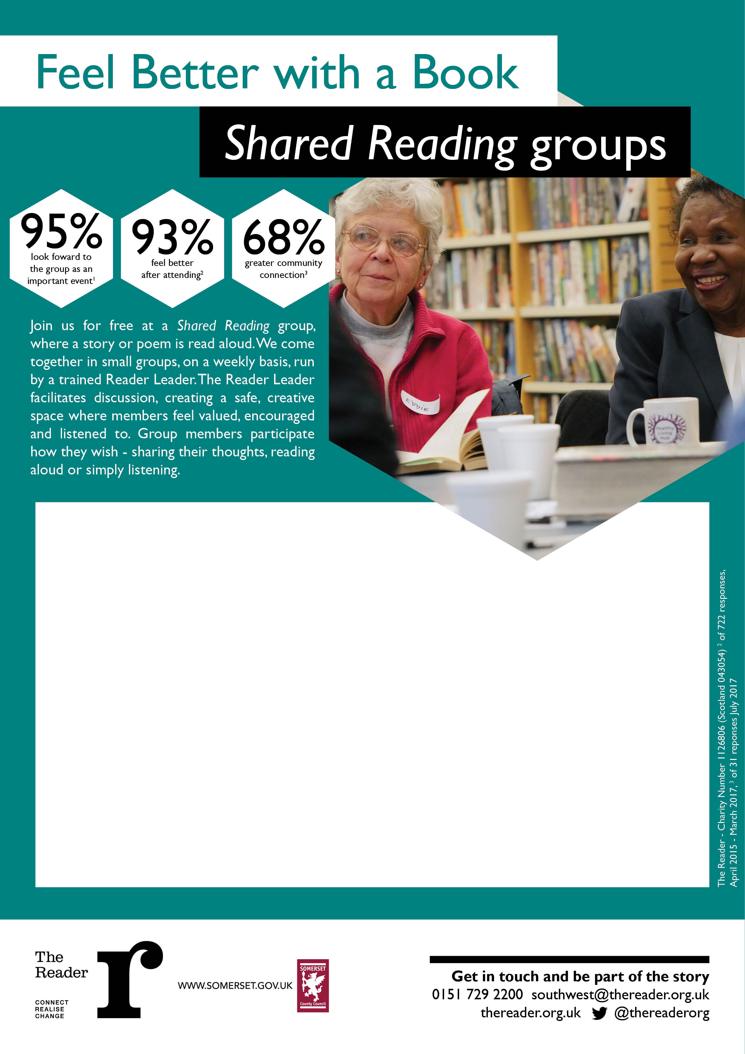

For more information, contact Emma Crago:

[emmacrago@thereader.org.uk](mailto:emmacrago@thereader.org.uk) / 07970 247410

Mondays, 11am-12:30pm

Glastonbury Library

Mondays, 1:30-3pm

Chard Library

Mondays, 2-3:30pm

Taunton Library

Mondays, 2-3:30pm

Cheddar Library

Memory Groups:

Mondays, 11am-12:30pm

Taunton Library

Thursdays (fortnightly), 11am-12:30pm

Yeovil Library

Tuesdays (fortnightly), 2-3:15pm

Wincanton Library

Tuesdays, 2-3:30pm

Bridgwater Library

Wednesdays, 11am-12:30pm

Yeovil Library

Fridays, 11am-12:30pm

Wells Library

Your local *Shared Reading* groups: